Alternative Payments For
Matt Valentine-Chase Therapy
Crypto:
USDT: Send To Address:
4CGNoW8ZFveXQVvkiQ38HexYvbkB1zP2a8mpg6thMccz

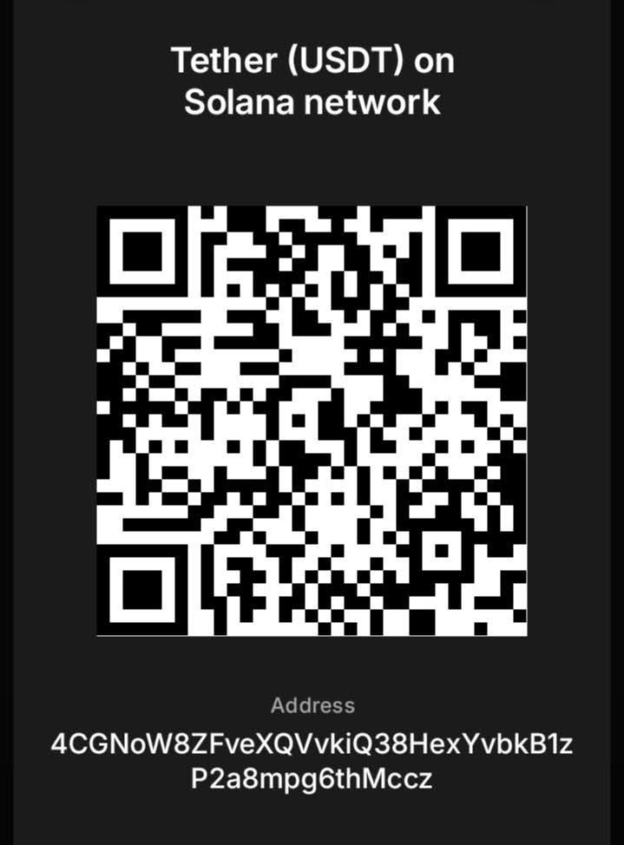

Or Scan QR
NB: (Tether Solana Network)
For Bitcoin see next page.
Alternative Payments For
Matt Valentine-Chase Therapy
Crypto:
Bitcoin: Send To Address:
bc1qzqznv9qq7htaumqn7eqzkt96zveqaenq86v6u7

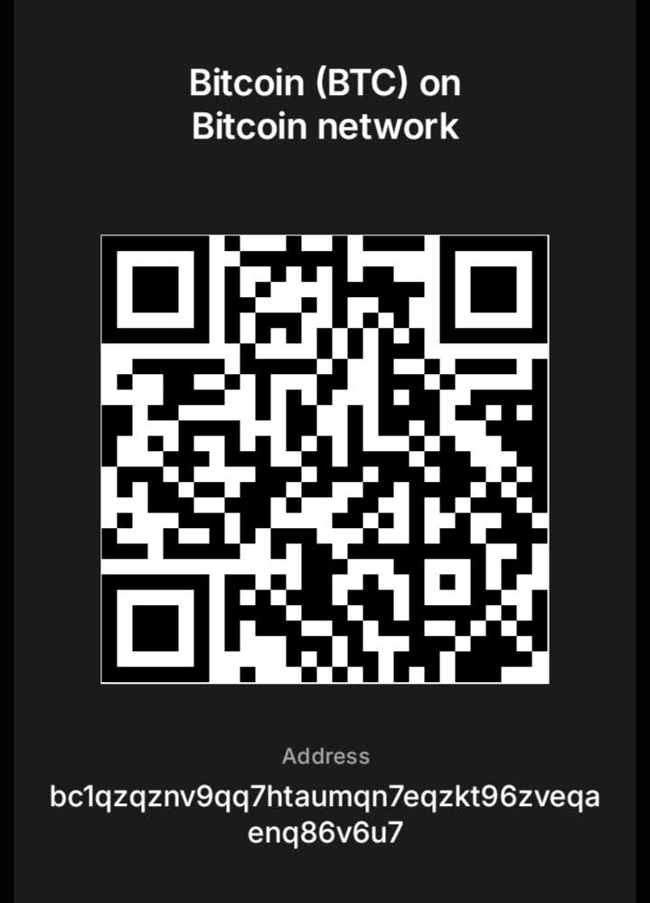
Or Scan QR
Please see next page.
A Note on Crypto & Alternative Payments

First-time crypto payments
Send a small test amount first, then message me on +44 (0)7716 232865. Once I confirm receipt, send the rest. This is standard practice to verify the address.

I accept many cryptocurrencies beyond those listed — just ask for the address of your preferred coin.

New to crypto?
Stablecoins (e.g. USDT, USDC) and Bitcoin are generally the most popular choices due to their relative stability.

Other options
I also accept Goldbacks and precious metals (by post). This will mean a longer wait for your appointment until delivery is confirmed.
Please enquire if interested.
Questions?
Email:
• matt@sexcoaching.london (sex-related)
• iammattvc@therapist.net (general therapy)

© 2026 Matt Valentine-Chase.

